WIND HORSE TOURS: FRONT END WEB-DEVELOPMENT AT

HALFTONE DESIGNS PVT. LTD.



By

**Urgen Sherpa (T.U. Exam Roll No. 3328/070)**

*An Intern report submitted in partial fulfillment of the requirements for the degree of Bachelor of Science (B.Sc.) in Computer Science and Information Technology Awarded by IOST, Tribhuvan University.*

**Sagarmatha College of Science & Technology**

**Sanepa, Lalitpur**

**March, 2018**

WIND HORSE TOURS: FRONT END WEB-DEVELOPMENT

(CSC-452 Internship)



An internship report submitted in partial fulfillment of the requirements for the

Degree of Bachelor of Science (B.Sc.) in

Computer Science and Information Technology

Awarded by IOST, Tribhuvan University

**Submitted to**

Department of Computer Science and Information Technology

Sagarmatha College of Science and Technology

Tribhuvan University

**Submitted by**

Urgen Sherpa (T.U. Exam Roll.No.3328/70)

# MENTOR’S RECOMMENDATION

I hereby recommend that the final year internship report on front end web development entitled “**Wind Horse Tour**” carried out at **Halftone Designs Pvt. Ltd.** by **Mr. Urgen Sherpa** can be processed for the evaluation of fulfilling the partial requirements for the degree of Bachelor of Science and Computer Science and Information Technology. In my best knowledge, this report is the record of the authentic work independently carried out by him during the internship period under my surveillance and mentorship.

..........................................

**Mr. Raju Maharjan**

Front-end web developer,

Halftone Designs Pvt. Ltd.,

Dillibazaar, Kathmandu, Nepal.

# SUPERVISOR’S RECOMMENDATION

I hereby recommend that this report has been prepared under my supervision by **Mr. Urgen Sherpa** in partial fulfillment of the requirements for the degree of B.Sc. in Computer Science and Information Technology be processed for evaluation.

…………………..…

**Er. Manish Aryal**

Associate professor,

Department of Computer Science and IT

Sagarmatha College of Science and Technology

Sanepa, Lalitpur

# CERTIFICATE OF APPROVAL

The undersigned certify that they have read and recommended to the Department of Computer Science and Information Technology for acceptance, an internship report submitted by **Mr. Urgen Sherpa** in partial fulfillment for the degree of Bachelor of Science in Computer Science & Information Technology.

|  |  |
| --- | --- |
| …………………………  Er. Manish Aryal  Ass. Professor, Sagarmatha College of  Science and Technology  (Supervisor) | …………………………  Er. Ganga Subba  H.O.D, Sagarmatha College of  Science and Technology  (H.O.D) |
| …………………………  Mr. Raju Maharjan  Front-end web developer  Halftone Designs Pvt. Ltd.  (Mentor) | …………………………  Mr. Bikash Balami  Asst. Professor CDCSIT, TU, Kirtipur  (External Examiner) |

# ACKNOWLEDGEMENT

Firstly, I would like to give my gratitude towards **Mr. Raju Maharjan,** my mentorfor assisting and inspiring to do the internship on front-end web development. Without their support and encouragement, it would have been difficult to work on.

I would also like to thank **Mr. Manish Aryal**, my Supervisor for his support and vision in making the intern a systematic one. He has been guiding and supporting me well.

I would also be thankful to my colleagues for their support and encouragement in the intern, who has supported us through his guidelines and experience. I would also be thankful to all the faculty members, for their intense support in fulfilling my internship requirements and also thankful to the library staffs of Sagarmatha college of science and technology for providing me with the necessary reference materials.

At the end, I would like to express my sincere thanks to all my friends and others who helped me directly or indirectly during this internship period.

Sincerely,

**Urgen Sherpa**

**T.U. Exam Roll No: 3328/070**

# ABSTRACT

This internship project is conducted for the partial fulfillment of the Bachelor of Science in Computer Science and Information Technology (B.Sc. CSIT) degree awarded by Tribhuvan University (TU). The internship is assigned for the evaluation as a part of the course requirement. The internship in specialized field provides us in-depth understanding about the field, market exposure and help to identify the potential career opportunities.

As for the partial fulfillment, I was interned as a front-end web developer in an organization named Halftone Designs Pvt. ltd. I was given the tasks of converting the layout of the web application “Wind horse tours”.

During my internship period, I have successfully completed the task of implementing the PSD template in web application under the supervision of Mr. Raju Maharjan. It was very exciting experience of working in the real time platform with the implementation of knowledge that I have gained in the college. It was really challenging. It was the experience of entering into professional life from student life.

Keywords: tour, PSD, responsive theming

# **Table of Contents**

MENTOR’S RECOMMENDATION i

SUPERVISOR’S RECOMMENDATION ii

CERTIFICATE OF APPROVAL iii

ACKNOWLEDGEMENT iv

ABSTRACT v

Table of Contents vi

List of Figures ix

List of Abbreviations x

Chapter 1: Introduction 1

1.1 Introduction of internship 1

1.2 Organization Overview 1

1.2.1 Contact Details 2

1.4 Problem Statement 2

1.3 Project overview 2

1.5 Objectives of the project 3

1.6 Scope/Limitation of the project 3

1.7 Responsibilities Assigned 3

1.8 Duration and work procedure for the projects 6

1.8.1 Time scheduling 6

Chapter 2: Analysis 7

2.1 Requirement Analysis 7

2.1.1 Functional Requirement 7

2.1.2 Non-functional Requirement 9

2.2 Feasibility Analysis 10

2.2.1 Technical 10

2.2.1 Operational 10

2.2.3 Economic 10

Chapter 3: System Design 11

3.1 Web interface 11

3.2 Site structure 12

3.3 Flowchart 13

Chapter 4: Implementation 14

4.1 Front-end tools 14

4.2 Back-end tools 14

Chapter 5: Testing 16

5.1 Testing Methods 16

5.1.1 Unit Testing 16

5.2.2 Integration Testing 16

5.2 Responsive theming test 16

5.3 Cross-Browser Testing 18

Chapter 6: Conclusion and Future scope 19

REFERENCES 20

APPENDICES 21

Screenshot of the application 21

# List of Figures

Figure 1 - General architecture of PSD to html/CSS 4

Figure 2-Flowchart(a) 4

Figure 3-Flowchart(b) 5

Figure 4-work schedule 6

Figure 5-use-case diagram(customer) 8

Figure 6-use-case diagram(admin) 9

Figure 7-web interface design 11

Figure 8-Site structure 12

Figure 9-application flowchart 13

Figure 10- responsive design 17

Figure 11-cross-browser platforms 18

Figure 12-Homepage 21

Figure 13- online payment 21

Figure 14-online booking 22

Figure 15-view trips 22

# List of Abbreviations

PSD Photoshop Document

UI User-Interface

UX User-experience

HTML Hyper Text Markup Language

CSS Cascading Style Sheets

PHP Personal Home Page

MySQL [Structured Query Language](https://en.wikipedia.org/wiki/Structured_Query_Language)

# Chapter 1: Introduction

## Introduction of internship

An internship is an opportunity offered by an employer to potential employees, called interns, to work at a firm for a fixed, limited period of time. Interns are usually undergraduates or students, and most internships last for any length of time between one week and 12 months. Internships offer students a hands-on opportunity to work in their desired field. They learn how their course of study applies to the real world and build a valuable experience that makes them stronger candidates for jobs after graduation.

With the aim of acquiring hands-on training in the web designing and development, the author had done internship at Halftone Designs Pvt. Ltd. as front end web developer. The objectives of the internship are as follows:

* To experience and understand the work ethics, professional standard and technology used by an organization to achieve their goals.
* To get knowledge and experience in handling real world project.
* To become competent in order to land permanent job in related fields.

## 1.2 Organization Overview

**Halftone Designs Pvt. Ltd. is one of the leading website design and development company of Nepal. This company was founded in 2011 and is located at Dillibazaar - Kathmandu, Nepal.**

**Halftone Designs mainly provide services regarding graphic designing, logo designing, website designing, web application development, Ecommerce solutions and web application maintenance. In addition to this, the company has also run training classes in the field of graphic designing, web designing, web application development, mobile application development etc. The contact information of the company are as follows:**

### ****1.2.1 Contact Details****

* Halftone Designs Pvt. Ltd.
* Physical address: Abhiyan Marg, Kathmandu, Nepal
* Telephone: +977-1-4421754/+977-9851142573/+977-9803042573
* Website: http://htd.com.np/
* Email: info@htd.com.np
* Facebook: <https://www.facebook.com/halftonedesigns/>

## ****1.4 Problem Statement****

Most of the people love to travel, trek and tour to new places and countries. For the purpose of trekking or tour, people used to contact the travelling and trekking company for getting authentic information, hassle-free trekking, sense of security, expert consultation etc. So, the trek and tour companies need reliable and effective medium to provide the detail information about their background, their provided services and more information regarding trek and tours. Furthermore, they also need an effective medium to provide consumer-oriented services like checking the availability of trips and tours, reservation and payment gateways.

The web application should follow the latest designs trend. The most effective and efficient designs improve the readability of the content and provides the most useful information to the user. Similarly, the web application should improve the readability of its content and enhance search engine optimization.

## 1.3 Project overview

“Wind horse tours” is a web-based application which aims to provide the information of the services it provides to the trek and tour lovers. Basically, it is a tour operating company which was officially launched in Bhutan in 1998 to provide trek and tour services. The trek and tour services are provided in four different countries which are Nepal, Bhutan, India and Tibet.

## 1.5 Objectives of the project

The objectives of the project to be done during internship are as follows:

* To update the designs of the web application according to the latest trends.
* To improve the user UI and UX.

## 1.6 Scope/Limitation of the project

Now-a-days web application acts as a bridge between the customer and the companies. Web application provides all kinds of information and the services the user needs. The project wind horse tours help users to find all types of tours and treks details, their availability, date, reservation, payment and news etc. The interface of wind horse tours is smooth, user friendly and very efficient. The customer can easily find all the information and services they need from this web application without any difficulties.

There is limitation of this application also which are listed below:

* Internet connection required.
* User must know English language.
* Web browser is must in order to browse the web application.

## 1.7 Responsibilities Assigned

The author had done the front-end part of the project i.e. to convert PSD template file to html5/css3 and to add responsive theming by using fluid grids, fluid images and media query.

First of all, before the actual development process, website template is designed by graphic designer using photoshop. Then the actual development process of photoshop template to website begins using html5 and css3. After that, JavaScript and jQuery is used in order to add interactivity, animations and other effects to the static page.

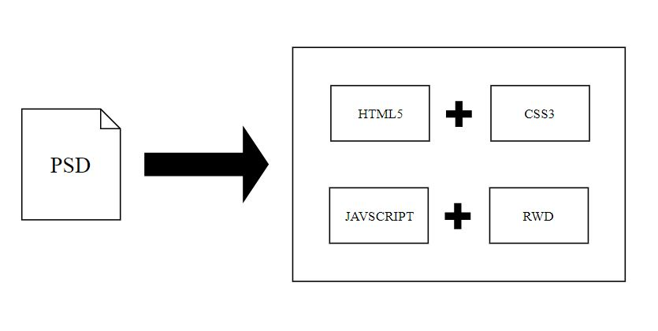

Figure - General architecture of PSD to html/CSS

The above figure shows the general architecture of PSD to html/CSS conversion. For the better understanding, the workflow of the process and steps taken in front end development are shown by the flowchart below:

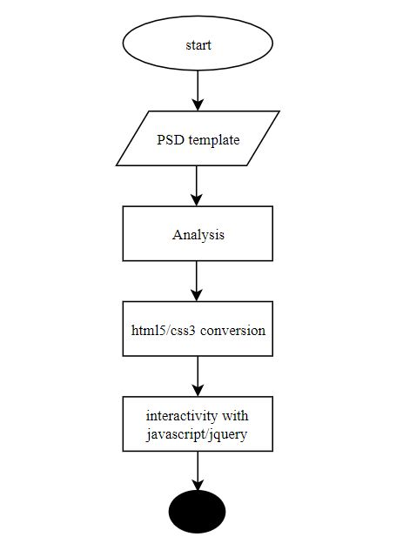

Figure -Flowchart(a)

The above figure is the first part of the flowchart which shows the initial phase of converting PSD template to html5 and css3. After converting it to html and CSS, further process of adding animation, effects and interactivity is done through JavaScript and jQuery.

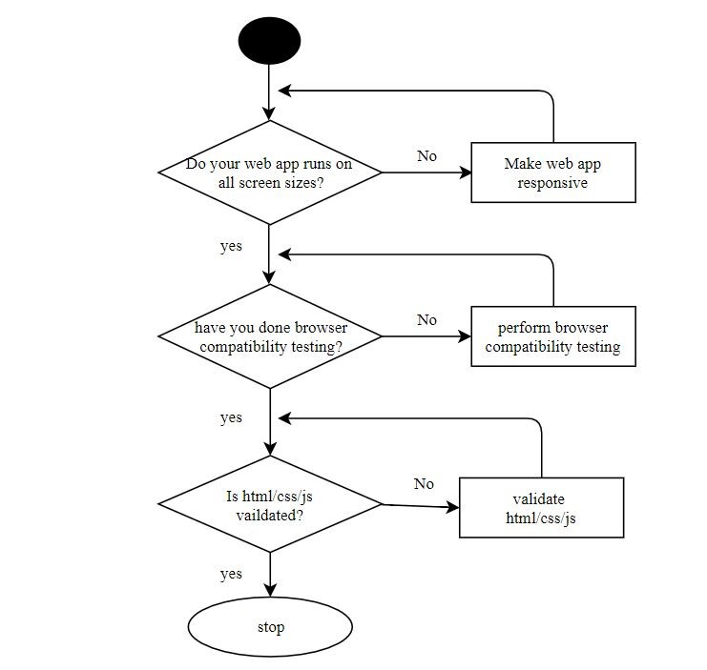

Figure -Flowchart(b)

The above flowchart is the last part of the flowchart which shows the final phase of task of front end web developer. When the development or coding part of the user interface from PSD template is finished, then responsive design is added which should be compatible to all screen sizes. After that browser compatibility is tested and validation of html, CSS and JavaScript is done online.

## 1.8 Duration and work procedure for the projects

|  |  |
| --- | --- |
| Start date | 23rd Ashwin, 2074 |
| End date | 20th Magh, 2074 |
| Position | Front end developer |
| Mentor | Mr. Raju Maharjan |
| Supervisor | Manish Aryal |
| Office hour | 10:00am – 5:00 pm |

### 1.8.1 Time scheduling

The time schedule for the internship and the work that have been done during the internship are as follows:

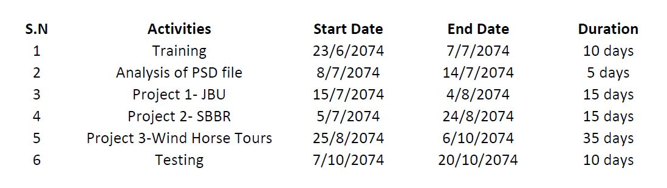

Figure -work schedule

# Chapter 2: Analysis

## 2.1 Requirement Analysis

Requirement analysis is the process of precisely identifying, defining, and documenting the various requirements that are related to a particular business objective. Requirements gathering helps in clearly understanding the needs of the customer, defining the scope of the project, and assessing the timescales and resources required to complete it. There are two types of requirement which are as follows:

### 2.1.1 Functional Requirement

What the system must do is termed as functional requirement. Functional requirements state the services that the system provides. It states how the system should react to particular inputs and how the system should behave in particular situation. The functional requirement of the web application are as follows:

1. Search trips: A user should be able to search the tours and trips based on destination, trip type, activity type and date.
2. View trips: The user should be able to view the details of the trips on request.
3. Check availability: The user should be able to check if the particular trip is available or not.
4. Customization of trips: The user should be able to customize the trips according to his/her interest.
5. Reservation: The user should be able to reserve/book the trips and tour.
6. Give payment: The user should be able to give payment through the available payment services via secure channel ensuring the security of user details.
7. Feedback: The user should be able to provide feedback based on the services, facilities and experience they get after using the services from the company.

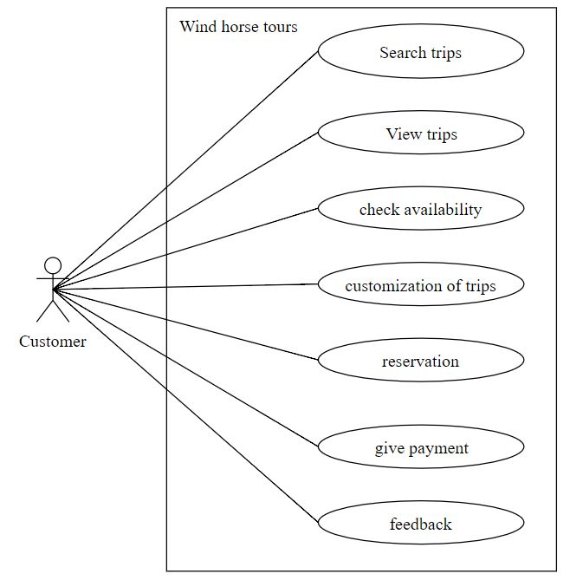

Figure -use-case diagram(customer)

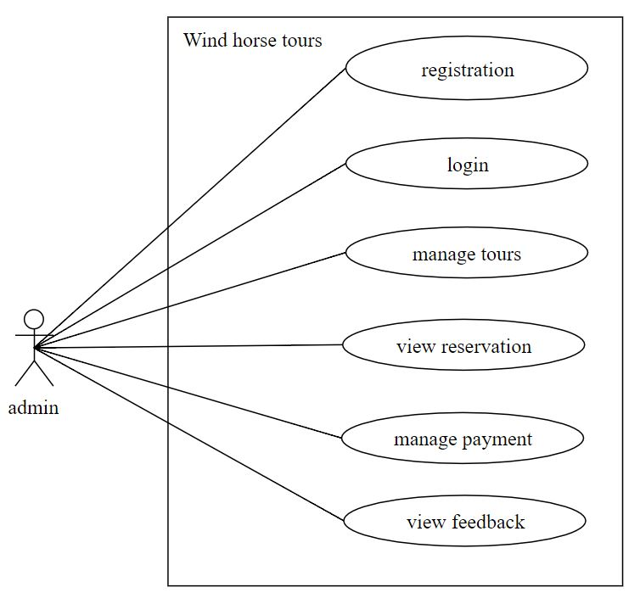

Figure -use-case diagram(admin)

### 2.1.2 Non-functional Requirement

Non-functional requirement are the requirements that are not directly concerned to the specified function delivered by the system. They may relate to the emergent system properties such as reliability, response time and store occupancy. Following are few non-functional requirements for wind horse tours:

1. The system should be implemented as a standalone web application.
2. The system should be compatible with the latest and oldest browsers.
3. The system is independent. It is not being integrated with any other software.
4. The system should secure the data and information of the client.

## 2.2 Feasibility Analysis

Feasibility study is a test of system proposed according to its work ability, impact on the organization, ability to meet user needs, and effective use of resources. The feasibility study of this application which had been carried out are as follows:

### 2.2.1 Technical

The application is technically feasible because the web application can be accessed through any devices like mobile, tablet, laptop etc. in the presence of internet. The application is developed by software developers using the current existing tools and technology and servers are cloud-based server.

### 2.2.1 Operational

This application is operationally feasible because the user/customer can get all the information and services it needed by using this web application. Through this application, the user can get the information of the background of the company and the services it provides and can use the services efficiently.

### 2.2.3 Economic

Economic feasibility is the analysis of a project's costs and revenues in an effort to determine whether or not it is logical and possible to complete. This application is economically feasible because this application is made using open source software and the server is hosted on cloud which is cheaper than traditional way of buying and maintaining the server.

# Chapter 3: System Design

System design is important in software development because it defines the architecture, components, modules, interfaces and data for a system. The system design of the project is defined by following subtopics:

## 3.1 Web interface

The web interface is the interface between the user and the software. The web interface is displayed through web browser which allows the users to interact with the system. The web interface of the application is based on grid-based layout. Html5 has been used for structuring the layout, text and images and CSS has been used for applying the grid-layout and design as defined by the PSD template file of the project.

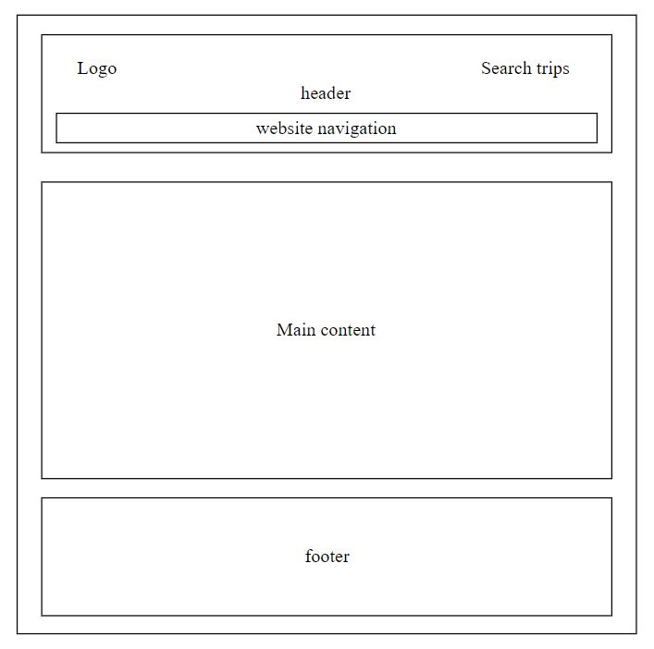

Figure -web interface design

The above figure tells about the basic web interface of the application. On the top, we have header which is contained by the company logo, trips search bar and navigation bar. On the center, there is the presence of the main content which contains all the information, forms, pictures etc. Basically, the main content is the place in which actual information about the trips, company etc. is located. And on the, bottom there resides the footer which mainly contains the contact details, its main and branch office location and link to social networking site.

## 3.2 Site structure

A clear, logical website structure aids navigation and orientation. The site structure tells how the individual subpages are linked to each other. The structure of the web page are as follows:

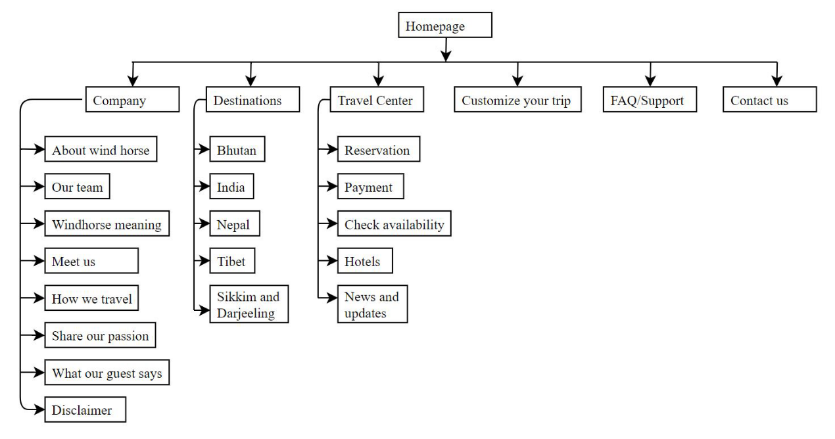

Figure -Site structure

The above site structure of the web application refers all the major section and its respective subpages. The major section also acts as navigation bar in the application. On the top, there is the homepage and on the second level, there is the navigation bar or major sections of the page which leads to its subpages.

## 3.3 Flowchart

The flowchart is a diagram which describes about the sequence of the movements or actions of the people or things involved in complex system. Following is the flowchart of the application:

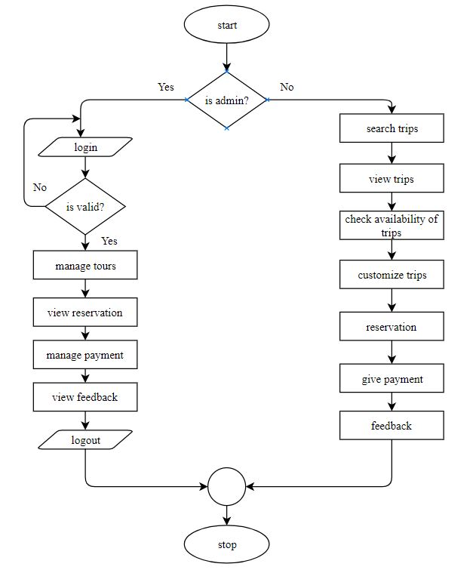

Figure -application flowchart

First of all, when the user enters into the system, then he/she have to authenticate him/herself as an admin by entering the valid credential in the system if he/she is admin otherwise if he/she is the normal user then he/she can use the service provided by the web application. The admin can manage the tours, view reservation, manage the payment and view feedback. Similarly, the user can search for trips, view trips, customize trips, book the trips, give payment and feedback as well.

# Chapter 4: Implementation

## 4.1 Front-end tools

The front-end tools and technologies used in this project are as follows:

1. Photoshop cc 2017

Photoshop cc 2017 has been used to measure the pixel value of the layout and to extract the image/logo.

1. Sublime text 3

Sublime text 3 has been used as text editor to code html, CSS and JavaScript.

1. Html5

Html5 has been used to create the basic structure and content of a webpage. It marks the contents up into different structural types, line paragraphs, blocks, lists, images, tables, forms, comment etc.

1. Css3

Css3 has been used to design the contents of a webpage. It tells the browser how each type of element should be displayed, which may vary for different media (like screen, print or handheld device.

1. JavaScript/jQuery

JavaScript has been used to define the interactive elements of a webpage that helps to engage user. It tells the browser how to change the web page in response to events that happen. jQuery is JavaScript library. The purpose of jQuery is to make JavaScript easier to use on website.

## Back-end tools

1. PHP

PHP has been used as a programming language to develop the back-end(server-side) part of the web application.

1. Apache

Apache is free and open source cross-platform web server and it has been used as the web server of the application.

1. MySQL

MySQL is an open-source relational database management system. It was used to store the data of the whole website entered by the hotel interns.

1. InMotion Hosting

InMotion hosting has been used to host the web application.

# Chapter 5: Testing

Testing is the process of verifying that the program works as intended and discover bugs before it is released. Number of tests is conducted to ensure the system is error free. The different modules are first tested independently and after that integrated those modules and tested it as a whole system.

## 5.1 Testing Methods

### 5.1.1 Unit Testing

Unit testing is a [software testing](https://en.wikipedia.org/wiki/Software_testing) method by which individual units of [source code](https://en.wikipedia.org/wiki/Source_code), sets of one or more computer program modules together with associated control data, usage procedures, and operating procedures, are tested to determine whether they are fit for use. Unit testing has been done testing individual activity of the application.

So, the unit testing was performed in each module of the application ensuring that each module work independently. Individual module was also tested in difference browsers ensuring consistent layout and result.

### 5.2.2 Integration Testing

Integration testing is a [software](http://searchsoa.techtarget.com/definition/software) development process in which program units are combined and tested as groups in multiple ways.

The integration testing was performed by combining the modules in single layout/page like homepage, contact page, destination page etc. the single page which combines the various modules were tested against different browsers like chrome, Mozilla, safari etc. and result obtained in all of these browsers were same.

## 5.2 Responsive theming test

The number of people using tablets and mobile devices instead of desktop computers to browse the internet is increasing day by day. So, web developers must ensure that the web application run smooth on all screen sizes. Therefore, the web application must be tested against different screen sizes.



Figure - responsive design

The web application was tested against multiple screen sizes ranging from small screen size phone(320px) to large screen devices(1440px). Mobile-first approach was followed while doing the responsive theming. The result of responsive theming test are as follows:

* All website images have got correct display size on the difference screen sizes.
* The size of images, text and other website blocks were proportionally changed in accordance with the screen sizes.
* The color of all site elements was preserved, despite the extension and characteristics of the screen.
* When a user enters text, it was displayed correctly with the size of pins, font, and tabs.
* correctness of the color reproduction was preserved when interacting with the interface.
* The page was scrolled without any problems and failures.

## 5.3 Cross-Browser Testing

Cross-browser testing means testing the browser against all modern browsers ensuring the consistent layout.

So, the web application was tested against multiple browsers and the layout was preserved in all browsers including chrome, Firefox, safari, opera and internet explorer.



Figure -cross-browser platforms

# Chapter 6: Conclusion and Future scope

Internship being a part of course requirement of B.Sc. CSIT education of Tribhuvan University has provided an important opportunity to the students to get the experiences in the real world along with the graduate theoretical knowledges. Through-out my internship, I have learned about the various aspects of front end part of web development.

The project “wind horse tours” is designed for the tours and treks lover to make it easy to contact and use the services offered by the wind horse tours. The website had given nice interface and it was tested against multiple browsers and on multiple screen sizes ranging from small sized mobile devices to large desktop sizes. The web application provides all the essential information needed by the users and it is easy to browse the different options and functionality provided by web application.

# REFERENCES

(n.d.). Retrieved from developer-mozilla: https://developer.mozilla.org/en-US/

Christensson, P. (2013, 2 5). *1*. (Sharpened productions) Retrieved 12 9, 2017, from https://techterms.com/definition/web_design

Coyler, C. (n.d.). Retrieved from https://css-tricks.com/

Duckett, J. (2013). HTML and CSS. In *HTML and CSS.* John Wiley & Sons, Inc.

*internship.* (2017, 3 20). Retrieved 11 28, 2017, from wikijob: https://www.wikijob.co.uk/content/internships/advice/what-internship

Marcotte, E. (2011). Responsive web design. In *Responsive web design.* Jeffrey Zeldman.

Roberts, H. (2017, 6 20). *css guidelines*. Retrieved 11 23, 2017, from https://cssguidelin.es/

Things, J. A. (2017). *responsive design*. Retrieved 1 5, 2018, from https://responsivedesign.is

*w3school*. (n.d.). Retrieved from w3school: https://www.w3schools.com

# APPENDICES

## Screenshot of the application

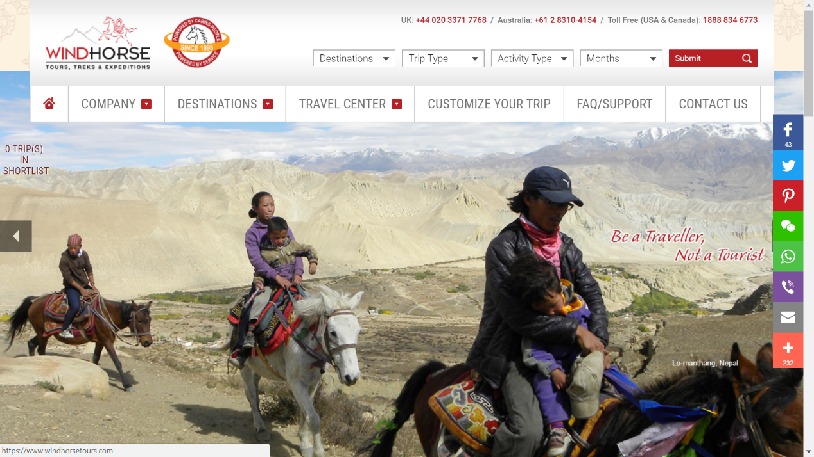

Figure -Homepage

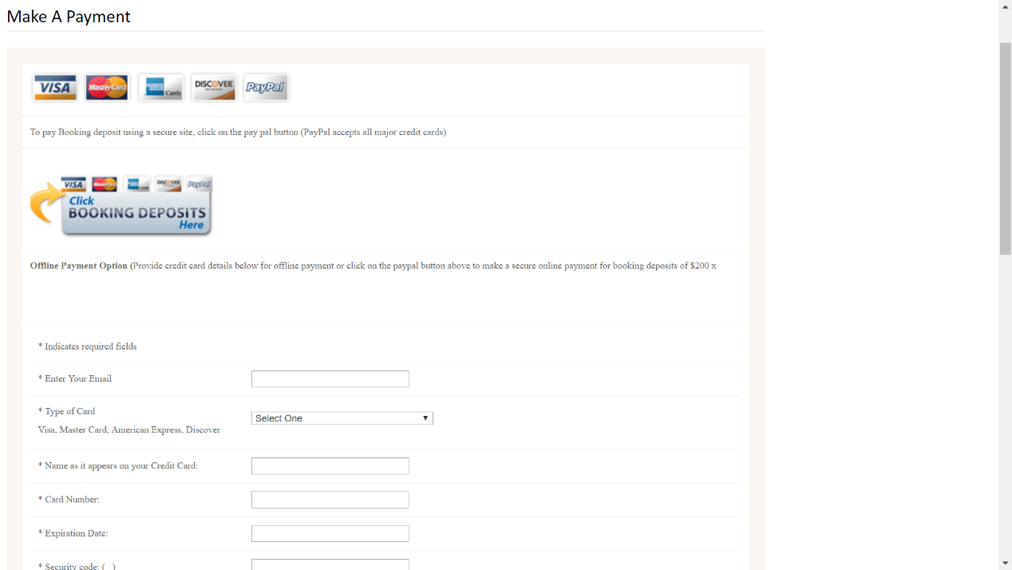

Figure - online payment

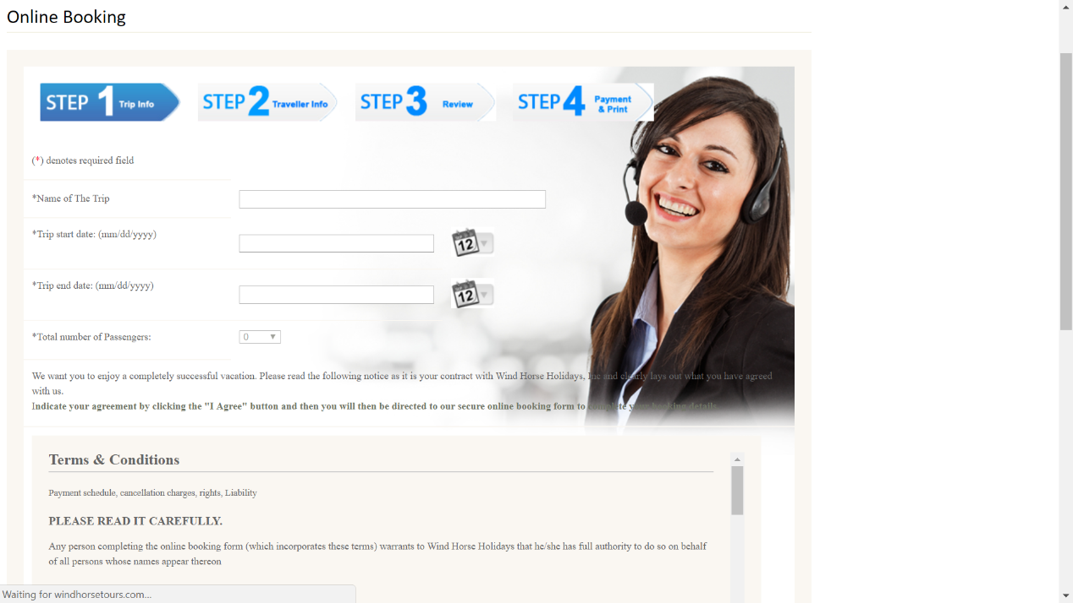

Figure -online booking

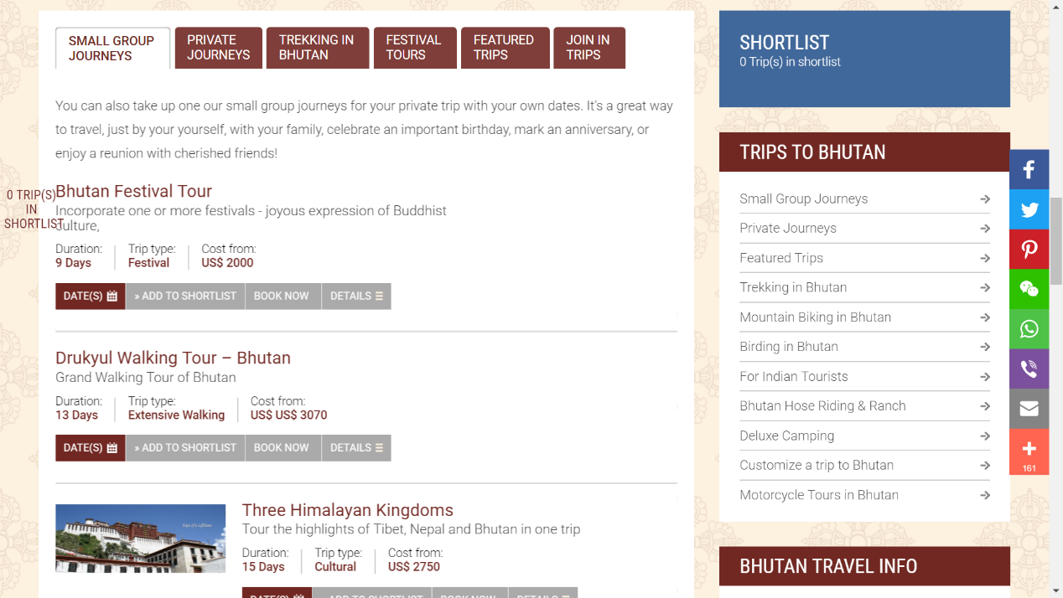

Figure -view trips